**RESETTING USER AGENT STYLESHEETS**

Designing a website across browsers with different user agent stylesheets can be a frustrating experience. To avoid this problem, it's very common to *reset* the user agent stylesheets using a CSS *reset stylesheet* (often shortened to "CSS reset").

CSS resets remove all browser-added styling to make sure that all content starts at the same starting point for developers. Using a CSS reset stylesheet can be accomplished using the following steps:

1. Create a **reset.css** file.
2. Copy and paste CSS reset rules into the **reset.css** file.
3. Link to **reset.css** in the HTML file (make sure **reset.css** is loaded first before other CSS files, otherwise **reset.css** may reset your custom rules by accident).

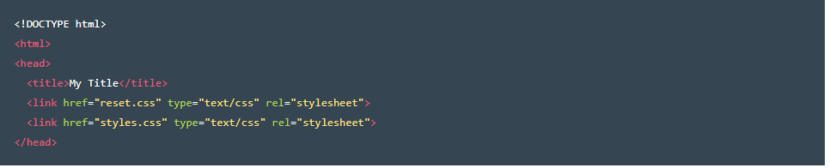

A popular CSS reset can be found [here](http://meyerweb.com/eric/tools/css/reset/).